NAME : WIJAYAWARDHANA W.A.H.A.

REGISTRATION NO. : 2019/E/166

SEMESTER : SEMESTER 05

DATE ASSIGNED : 23 AUGUST 2022

DATABASE SYSTEMS – LAB 01

EC 5070

DATABASE SYSTEMS

Code:

CREATE DATABASE LAB01_166;

use LAB01_166;

CREATE TABLE EMPLOYEE

( Fname VARCHAR(15) NOT NULL, -- Adding columns

Minit CHAR,

Lname VARCHAR(15) NOT NULL, -- NOT NULL means the domain must have a value

Ssn CHAR(9) NOT NULL, -- CHAR padded to 9 spaces

Bdate DATE, -- Date, YYYY-MM-DD

Address VARCHAR(30), -- Variable length CHAR array (string)

Sex CHAR, -- Single character

Salary DECIMAL(10,2), -- Decimal up to a precision of two decimal points

Super_ssn CHAR(9),

Dno INT NOT NULL, PRIMARY KEY (Ssn));

-- Primary key constraint);

CREATE TABLE DEPARTMENT

(Dname VARCHAR(15) NOT NULL,

Dnumber INT NOT NULL,

Mgr_ssn CHAR(9) NOT NULL,

Mgr_start_date DATE,

PRIMARY KEY(Dnumber),

UNIQUE(Dname),

FOREIGN KEY(Mgr_ssn) REFERENCES EMPLOYEE(ssn));

CREATE TABLE DEPT_LOCATIONS

(Dnumber INT NOT NULL,

Dlocation VARCHAR(30) NOT NULL,

PRIMARY KEY(Dlocation),

FOREIGN KEY(Dnumber) REFERENCES DEPARTMENT(Dnumber));

CREATE TABLE PROJECT

(Pname VARCHAR(50) NOT NULL,

Pnumber INT NOT NULL,

Plocation VARCHAR(50) NOT NULL,

Dnum INT NOT NULL,

PRIMARY KEY(Pnumber),

FOREIGN KEY(Dnum) REFERENCES DEPARTMENT(Dnumber));

CREATE TABLE WORKS_ON

(Essn CHAR(9) NOT NULL,

Pno INT NOT NULL,

Hours INT NOT NULL,

FOREIGN KEY(Essn) REFERENCES EMPLOYEE(Ssn),

FOREIGN KEY(Pno) REFERENCES PROJECT(Pnumber));

CREATE TABLE DEPENDENT

(Essn CHAR(9) NOT NULL,

Dependent_name VARCHAR(15) NOT NULL,

Sex CHAR,

Bdate DATE,

Relationship VARCHAR(15) NOT NULL,

FOREIGN KEY(Essn) REFERENCES EMPLOYEE(Ssn));

INSERT INTO EMPLOYEE values

('Nipuna', 'B', 'Vishwajith', '201901156', '1999-04-04', '17, Main Street, TY', 'M', 150000, '201601037', 1),

('Franklin', 'T', 'Wong', '201902164', '1946-12-08', '638 Voss, Houston, TX', 'M', 40000, '201901156', 2),

('Joyce', 'A', 'English', '201601037', '1962-12-31', '5631 Rice, Houston, TX', 'F', 25000, '201904290', 1),

('Ramesh', 'K', 'Narayan', '202004290', '1952-09-15', 'Fire Oak, Humble, TX', 'M', 38000, '201901156', 4);

INSERT INTO EMPLOYEE values

('James', 'E', 'Borg', '202001645', '1927-11-10', 'Stone, Houston, TX', 'M', 55000, NULL, 1),

('Jennifer', 'S', 'Wallace', '202103764', '1931-06-20', 'Berry, Bellaire, TX', 'F', 43000, NULL, 3),

('Ahmad', 'V', 'Jabbar', '201903423', '1959-03-29', 'Dallas, Houston, TX', 'M', 25000, '202103764', 3),

('Alicia', 'J', 'Zelaya', '201802185', '1958-06-19', 'Castle, SPring, TX', 'F', 25000, '201904290', 2);

INSERT INTO DEPARTMENT values

('Computer','1','201901156','2018-08-01'),

('Civil','2','201902164','2017-10-01'),

('Elec','3','201903423','2018-08-01'),

('Network','4','202004290','2020-08-01');

INSERT INTO DEPT_LOCATIONS values

('1','Jaffna'),

('2','Murukandy'),

('3','Killinochhci'),

('4','Vauniya');

INSERT INTO PROJECT values

('Syber Security','1001','Colombo','1'),

('Netwwork','1009','Vauniya','4'),

('Railway','1005','Kokavil','2'),

('AI','1004','Jaffna','1'),

('PCB Design','1003','Killinochchi','3');

INSERT INTO WORKS_ON values

('201901156','1001','35'),

('202103764','1005','45'),

('201802185','1009','15'),

('202004290','1003','40'),

('202001645','1004','20');

INSERT INTO DEPENDENT values

('201901156','John','M','1992-09-08',''),

('201802185','Haswahka','F','1995-04-07',''),

('201901156','Jaawahan','M','1999-10-29','');

SELECT * FROM lab01_166.employee;

SELECT Fname,Address

FROM lab01_166.employee

WHERE Salary > 30000;

SELECT Dname,Dlocation

FROM lab01_166.department , lab01_166.dept_locations

WHERE lab01_166.department.Dnumber = lab01_166.dept_locations.Dnumber;

Screen Shots:

01.

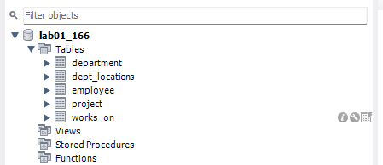

02.

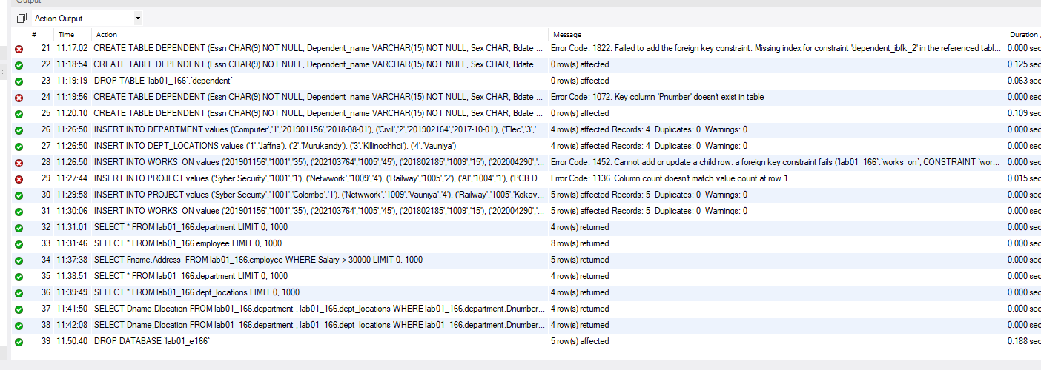

05.

a.

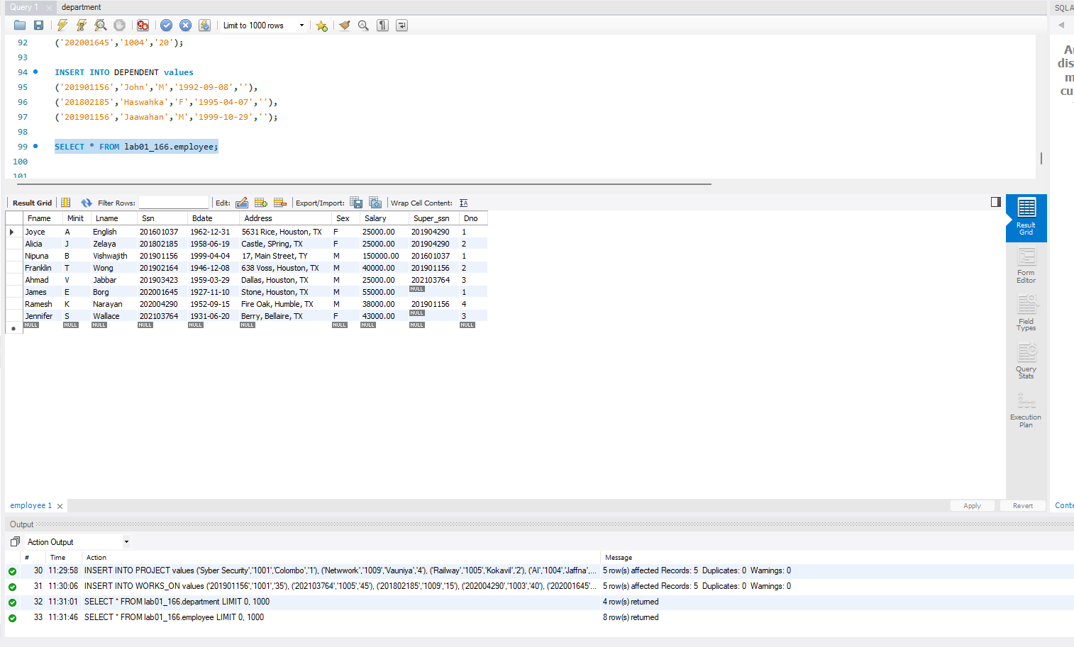

b.

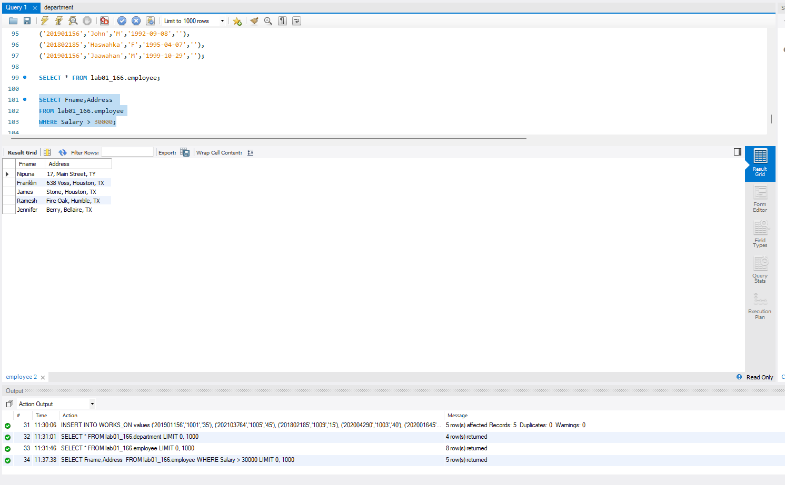

c.

